**Functionality Description**

**For**

**[SP Movies 2.0]**

**Date: [05/02/2023]**

**Contents**

**1 Document Management 3**

**1.1 *Contributors* 3**

**1.2 *Version Control* 3**

**2 OVERVIEW 4**

**2.1 Function Description 4**

**2.2 Technology 10**

**2.3 Development Tools and Processes 11**

**2.4 Interfaces and services 12**

**3 APPENDIX**

**3.1 Additional / Advanced features 15**

**3.2 Reference Links 16**

# Document Management

## *Contributors*

*Details of all contributors to this document*

|  |  |
| --- | --- |
| **Function Integrated** | **Name** |
| Function #1,2,3 | Ng Cheng Wai Melvin |
| Function #4 | Kua Zi Lin |
| Function #5 | Ng Chye Yong |
| Function #6, #7 | Ng Cheng Wai Melvin |
| Various additional features/functions | Ng Cheng Wai Melvin |
|  |  |

## *Version Control*

*Changes made to this document since creation.*

|  |  |  |  |  |
| --- | --- | --- | --- | --- |
| **Date** | **Version** | **Author** | **Section** | **Amendment** |
| 01/02/23 | 1.0 | Melvin | - | Initial Creation |
| 03/02/23 | 1.1 | Kua | 2.1 | Update Function 4 Function Description |
| 03/02/23 | 1.2 | NG CY | 2.1 | Update Function 5 Function Description |
| 04/02/23 | 1.3 | Kua | 2.4 | Update Function 4 Interface & Service |
| 04/02/23 | 1.4 | NG CY | 2.4 | Update Function 4 Interface & Service |
| 04/02/23 | 1.5 | Melvin | 3.1, 3.2 | Add new sections & Tidy up document |
|  |  |  |  |  |
|  |  |  |  |  |

# OVERVIEW

*A brief description of what the overall system is about from a business perspective.*

## Function Description

*High level description of what functionality the system contains (a list of the components / functionalities that have been integrated (frontend ↔ backend)).*

*This should include*

*i) a sequence diagram of the input / output between the User, Front End (i.e. the Website) and the Backend (i.e. the Server App).*

*ii) screenshots of the end to end process (i.e. what would be observed by the User)*

1. **Function #1 – Login functionality (WIP)**

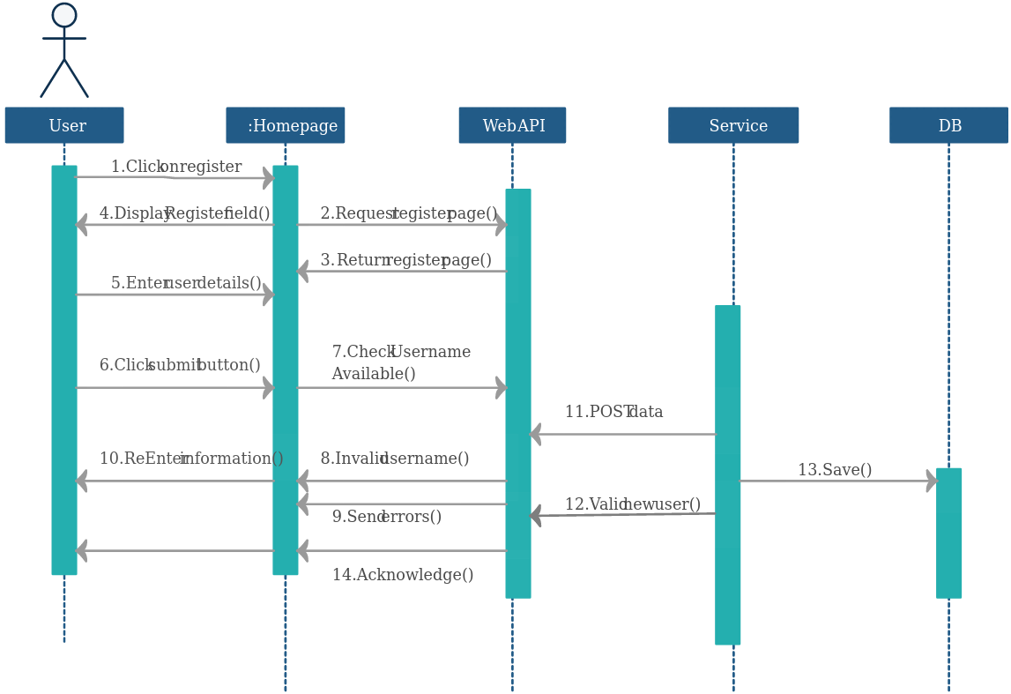

1. **Function #2 – Retrieve & Display a list of movies (WIP)**
2. **Function #3 – Update Movies (WIP)**
3. **Function #4 - Retrieve Movies and Sorting Z to A**

* Once the user is logged in, the user can use this function to retrieve the latest movies database from the server and display it in reverse order (Z to A).



* Before Sorting Z-A:

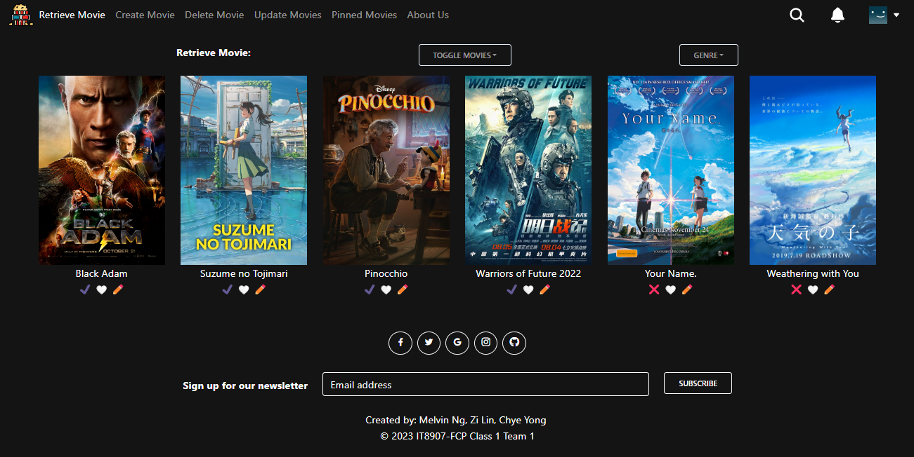

* 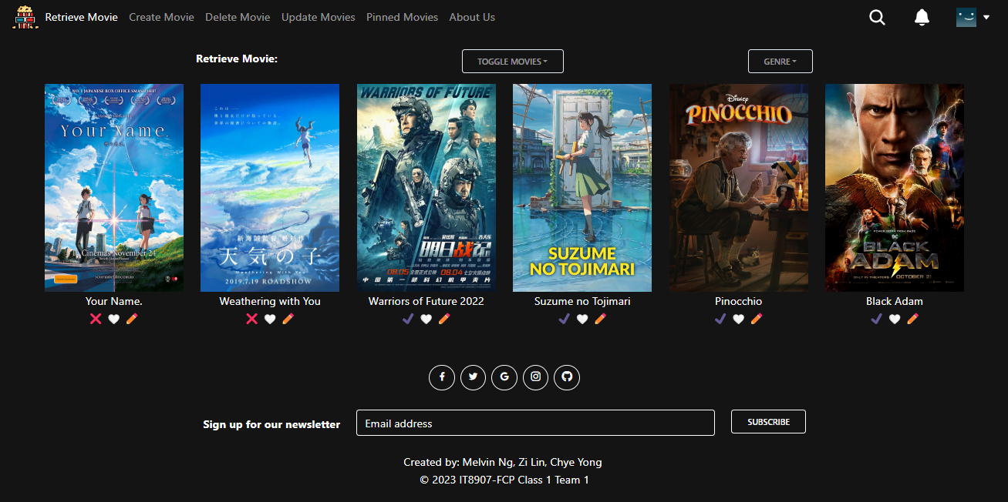After Sorting Z-A:

1. **Function #5 - Retrieve Movies and Sorting A to Z**

* Once the user is logged in, the user can use this function to retrieve the latest movies database from the server and display it inalphabetical order (A to Z).

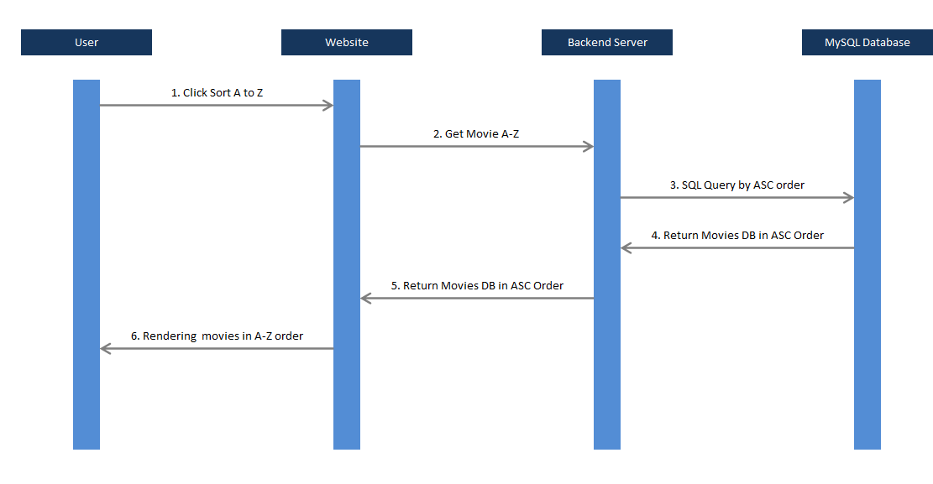

* Before Sorting A-Z:



* 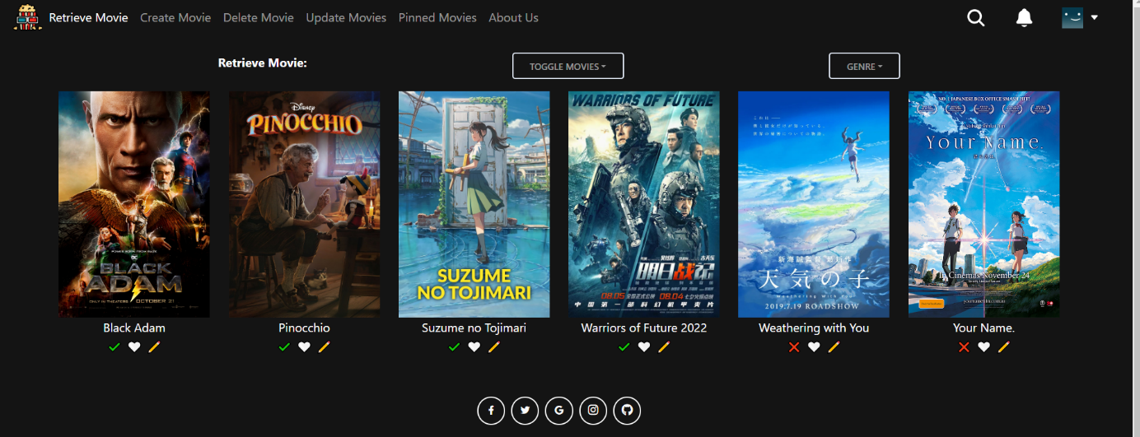After Sorting A-Z:

...

## Technology

*A listing and brief description of the underlying frameworks / libraries used by the application.*

## Development Tools and Processes

*This section should be used to document:*

* *any specific development tools, compilers or suggested IDEs that are used for the application.*
* *Describe how software source control is performed (e.g. Git)*

## Interfaces and services

* List all backend interfaces (incoming – data into the backend, outgoing – data out of the backend) and the path to the file (and lines of code) in which they are stored in.

| **Function Integrated** | **Details of Front End Codes** |  | **Details of Back End Codes** |
| --- | --- | --- | --- |
| Function #1 | Function.jsx (lines 20 to 30) | <-> | App.js (lines 10 to 15) |
| Function #4  (Retrieve & Sorting Z to A) | src/components/RootPage/Index.jsx  (lines 19-24 , 96-98 , 116-118) | <-> | controller/app.js  (lines 183-193) |
| src/redux/movieSlice.js  (lines 62-79 , 112-128) | model/movie.js  (lines 180-202) |
| src/utils/functions.js  (lines 439-461) |  |
| Function #5  (Retrieve & Sorting A to Z) | Src/components/RootPage/Index.jsx (lines 19-24, 88-90, 105-107) |  | controller/App.js (lines 171-181) |
| Src/redux/movieSlice.js (lines 44-60, 92-107) |  | model/movie.js  (lines 27-50) |
| Src/utils/functions.js (lines 404-432) |  |  |
|  |  |  |  |

# 

# APPENDIX

A brief description of what the additional / advanced features that were added in as well (beyond the scope of the CA1/CA2 requirements)

## Additional / Advanced features

High level description of what other additional / advanced functionalities the system contains.

This should include

i) a general description of the functionality in words.

ii) screenshots demonstrating how the functionality works (i.e. what would be observed by the User)

## Reference Links

For additional information, please kindly refer to the following links below:

GitHub Repository Link : <https://github.com/SP-CET-Capstone/capstone-assignment-class-1-team-1>

Our group’s README.md: <https://github.com/SP-CET-Capstone/capstone-assignment-class-1-team-1/blob/main/README.md>

Our group’s Kanban Board: <https://github.com/orgs/SP-CET-Capstone/projects/11>

Roles & Responsibilities of each team member (we worked together like a Scrum team): <https://github.com/orgs/SP-CET-Capstone/projects/11?pane=issue&itemId=19145533>